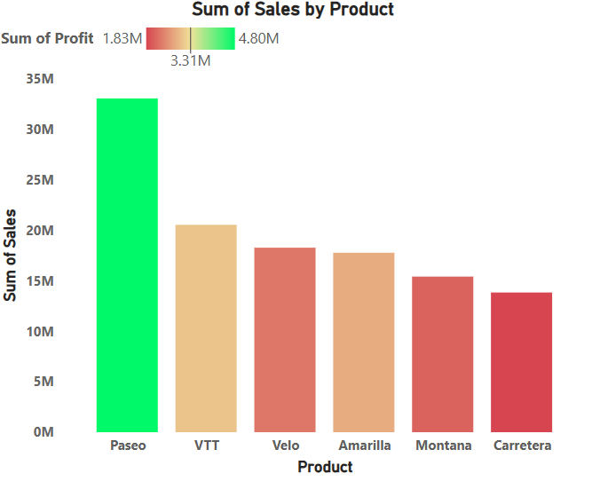

Conditional Formatting

**Steps:**

* **In Report View Tab**

1. Visualizations tab ->Build Visual
2. Click on **Stacked Column Chart**
3. **Data Tab**
4. **Financials** -> Select Column name according to the given question
5. **Build Visual**
6. X-axis -> Product
7. Y-axis -> Sales (sum)

* **Format Visual**

1. Format Visual -> visual

* **X-Axis:**
* **Values**

1. Font -> Segoe UI Bold
2. Size -> 10, Bold
3. Color -> Grey

* **Title**

1. Title Text -> Product
2. Style -> Show Title Only
3. Font -> DIN
4. Color -> Black

* **Y-Axis:**
* **Range** -> Auto
* **Values**
* Font -> Segoe UI Bold
* Size ->9, Bold
* Color -> Grey

1. **Title**

* Title Text -> Auto
* Style -> Show Title Only
* Font -> DIN
* Color -> Black
* **Legend:**
* Position -> Top left
* Text
* Font -> segoe UI (Bold)
* Color -> Brown
* Title -> Sum of Profit
* **Gridlines:**
* Horizontal -> **OFF**
* **Columns:**
* Categories : All
* FX
* Color – category
* Format style -> Gradient
* What field should we base this on -> Sum of profit
* Summarization -> Sum
* How should we format empty values -> Don.y format
* Minimum -> Lowest vale(red)
* Center -> middle value(yellow)
* Maximum -> Highest value(Green)
* Add a middle color -> tick
* **Border: Off**
* **Format Visual**
* Format Visual ->**General**
* Title -> Text -> Sum of Sales by Product
* Heading ->Heading 3
* Font -> DIN
* Size ->14, Bold
* Color -> Black
* Horizontal Alignment -> Center
* Text wrap -> on
* Header icon (on)
* Color
* Backround -> white
* Border -> white
* Icon -> Black
* Tooltips (ON)
* Type -> Report page
* Page -> Auto

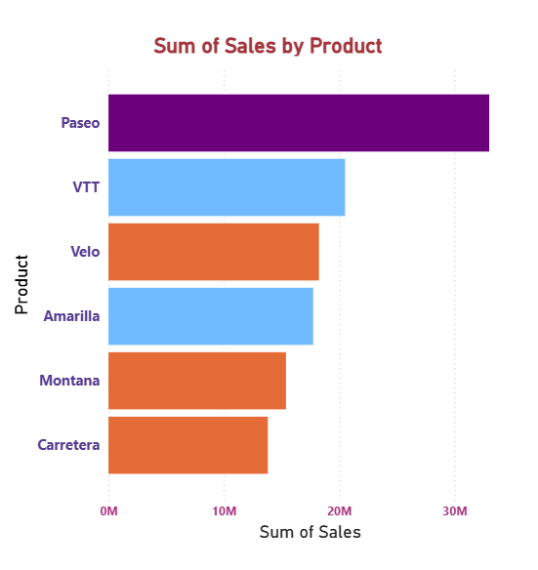

Conditional Formatting with Rules

**Steps:**

* **In Report View Tab**

1. Visualizations tab ->Build Visual
2. Click on **Stacked Column Chart**

* **Data Tab**

1. **Financials** -> Select Column name according to the given question

* **Build Visual**

1. X-axis -> Product
2. Y-axis -> Sum of Sales

* **Format Visual**

1. Format Visual ->Visual

* **Columns:**

Color -> Conditional Formatting

* **Color – Categories:**
* Format Style -> **Rules**
* What field should we base this on? -> **Sum of Profit**
* Summarization -> **Sum**
* If Value >= **35000,** Number and <= **5000000** Number then color: **Violet**
* If Value >= **25000**, Number and <= **3500000** Number then color: **Orange**
* If Value >= **15000**, Number and <= **2500000** Number then color: **Pink**
* then press OK button.